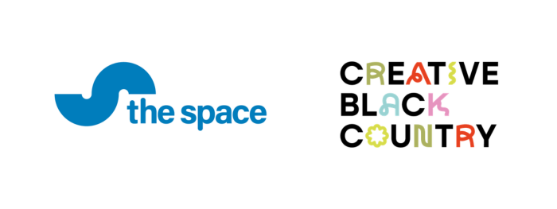
Making Our Mark
Walsall Beyond – A People and Places Digital Commission
A partnership commission between The Space and Creative Black Country as part of Making our Mark.

The deadline for submission is midday Monday 25th May 2026.

Successful applicants will be notified during the week beginning 6th July 2026

(Depending upon the volume of applications received, notification of the decision may be delayed).

If you have any questions, please contact the Making Our Mark Heritage Adviser via email: rayna@creativeblackcountry.co.uk

Section 1: Contact Details
- Applicant name

- Name of group or organisation delivering the activity.
Please include the name of the main contact for this project

- Contact telephone number.

- Contact Email address.

- Address for correspondence.

- Website / Social Media (if applicable)

Section 2: Your Proposal

- What is the name of your project?

- Please provide an outline of your project idea. Include what heritage stories your project will explore and how the project will involve your community group in the design and delivery of the activity.
(max 500 words)

- How will the project engage participants and the community in heritage activities who do not regularly engage in them? (max 200 words)

- What difference do you think this project will make to participants and your community? Consider how participants will benefit from skills development, connecting with heritage and community building. (max 300 words)

- How many people do you aim to engage, and how will you ensure a
quality experience for your group? How will you achieve this? (max 200 words)

- Where will your project take place?
Provide venue details or indicate if it will be an online or hybrid project. (max 100 words)

- How will you ensure your project is accessible?
(e.g. if it is digital, can you provide audio description, subtitles and/or BSL interpretation?). Please note, we will provide support and training for this. (max 200 words)

- What support do you need from the Making Our Mark team?
Examples: research guidance, networking support, access to training sessions. (max 200 words)

- How will you share your project and engage participants?
Include how you’ll use social media, local networks, or other methods (max 200 words)

Section 3: Your Timeline
- Project Start Date:

- Project End Date:

Please note, all projects must be completed within 8 months of receiving funding

Section 4: Budget
- Please provide a budget breakdown outlining how you will allocate your £18,000 grant. Include details such as admin, materials, travel, venue hire, experts/speakers’ fee or other project-related costs.

- Have you received money from CBC, The Space or The National Lottery Heritage Fund in the last two years? If so, please provide details. (max 100 words)

Frequently Asked Questions

1. How much funding is available?
You will receive £18,000 (inclusive of VAT), provided all project stages, including evaluation, are completed.

2. Do we need a bank account or insurance?
Yes, your group must have a community bank account and public liability insurance. Contact us for guidance if needed.

3. Who can apply?
Community groups and organisations that CAN submit applications:
- Voluntary organisations e.g. community groups or clubs, collectives, history societies, groups that meet regularly
- Heritage organisations, creative organisations
- Public organisations such as libraries, youth centres, etc.
- Organisations whose normal activity is not related to heritage but who want to include heritage in what they do, e.g. an allotment or residents’ association, a youth group, a senior citizens group
- Not-for-profit organisations and community groups, whether registered charities and CICs
- Faith groups/organisations
- Schools, i.e. affiliated parent/community groups. The activity should engage the wider community, and the grant cannot be used to subsidise work as part of the school’s curriculum

Who cannot apply?
The following organisations CANNOT receive support from this programme:
- Organisations that share out profits to members or shareholders
- University students using this grant to fund their heritage projects as part of their undergraduate or postgraduate course
- Those running activities that do not benefit people living in Walsall
- Activities that are already taking place or have already been completed (this must be a new activity)

Important information - if your application is successful:
You will need to provide us with a blank cheque/paying-in slip as proof of the official organisation’s bank account.
You will need to provide an official letter from your community group/organisation stating that the group’s lead has permission to sign contracts on its behalf.
Your group/organisation will need to complete short evaluation forms pre-project, and at the following stages: Explore, Make and Share (completion of the project).
You will need to provide basic documentation of the activity. This could be photographs, film, recordings and/or photography or online documentation, adhering to The National Lottery Heritage Fund Digital Licensing good practice guide. We will provide this information to support you with the process.
It is your responsibility to ensure you have all the necessary consents or permissions in place to undertake your project. We will provide you with our universal consent form.
You will need to be able to start your project as soon as you’ve been informed your application has been successful. We will get back to you as quickly as we can after the deadline.

4. Can we get help with our application?
Yes, email us to arrange a conversation with our Heritage Adviser - rayna@creativeblackcountry.co.uk

